主图+3-5张细节图
MODEL：(E)UROPE SERIES
标题：
Germany quality ebike conversion kit front wheel 36V 250w with battery internally

PRODUCT

New EU standard,DISCOVER OUR EBIKE AREAS E-ROAD/E-CITY
We want to pursue a European minimalist, classic and functional style.
LVCO electric bike system including motor, battery, controller, display, cable and other accessories. we provide complete kit that including everything you need to convert your bike into an ebike. The most simple makes the best ebike.

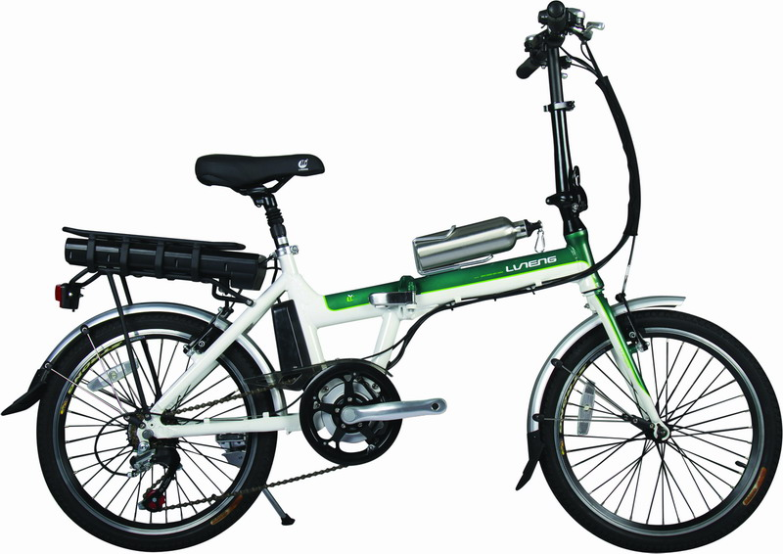
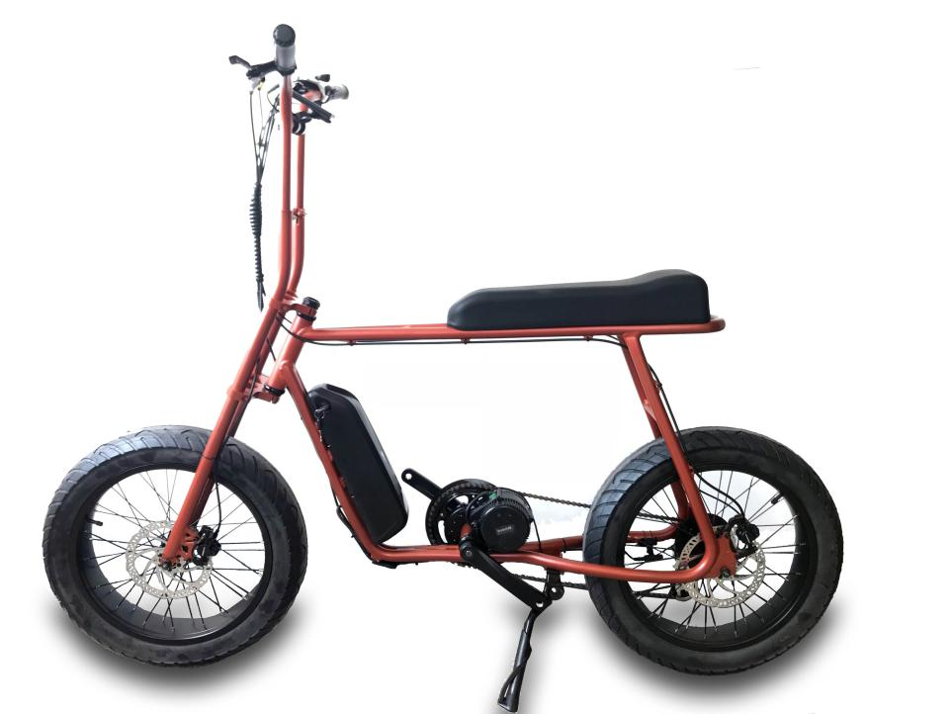
CONTROLLER INTERGRATED
CONTROLLER EXPOSED
CONTROLLER INTERGRATED

DETAILS
36V 250w with battery internally with lithium battery

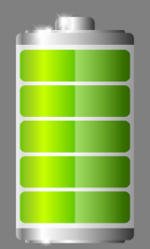
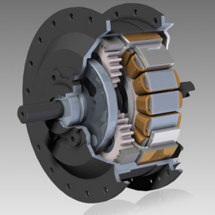
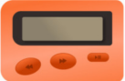
CONTROLLER
PAS

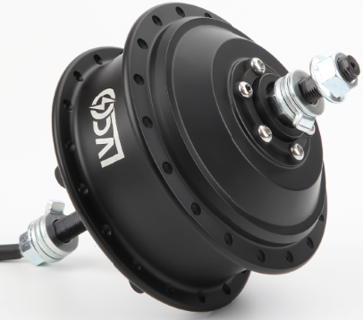

HB08F FRONT 36V 250W

brushless geared 36V/48V 250W/350W electric bike motor, which is 42N.m. The rated speed of this
motor is 25 km/h, which is comply with the road legal of most countries.

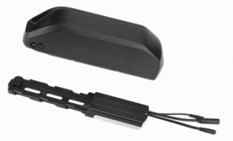
CONTROLLER
Controller build-in 36V 14A 6 mosfet reinforce power brushless controller with
Multiple functions features,sine wave and square wave for option

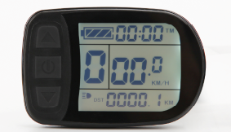
LCD
Important trip info displayed and all of the controller settings configured ,waterproof IP68

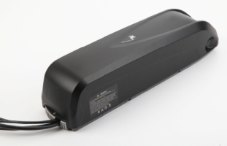
Battery HL battery 36V 13Ah
Branded 18650 cell lithium battery with high-quality BMS,RACK Type,Downtube and customized naked bag for option

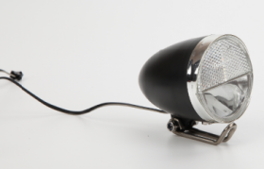

Integrated LIGHT Option

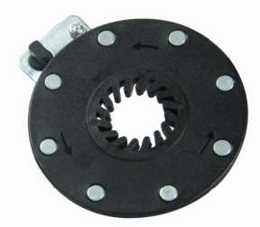

8 magnet PAS

