主图+3-5张细节图
MODEL：(A)MERICA SERIES
标题：
LVCO Brushless geared motor 16-28" 36v 350w conversion kit ebike with

lithium battery

PRODUCT

DISCOVER OUR EBIKE AREAS E-MTB/E-TOUR
LVCO electric bike system including motor, battery, controller, display, cable and other accessories. we provide complete kit that including everything you need to convert your bike into an ebike. The most simple makes the best ebike.

CONTROLLER INTERGRATED
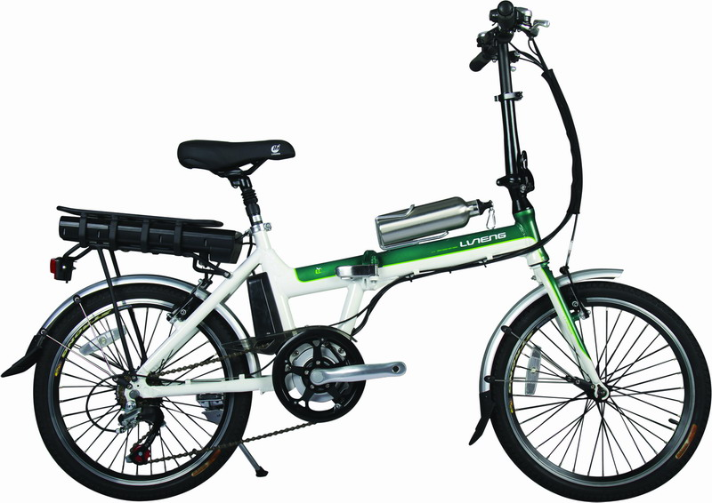
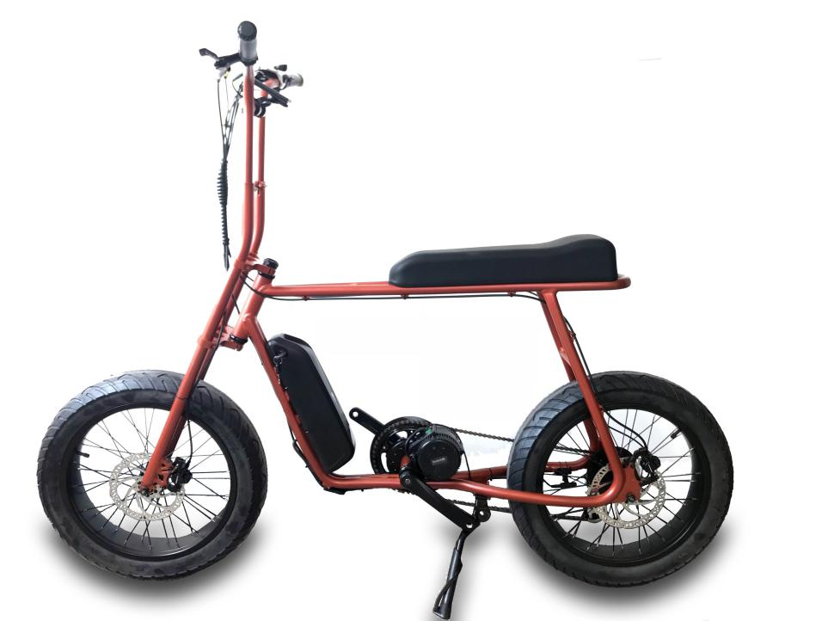
CONTROLLER EXPOSED
CONTROLLER INTERGRATED

DETAILS
36V 350W conversion kit ebike with lithium battery

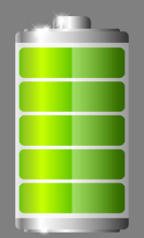
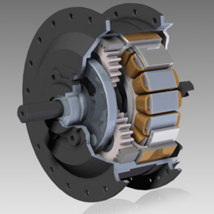
CONTROLLER
PAS

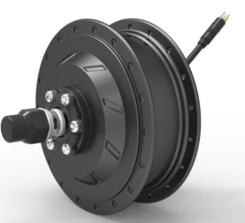

HB15 36V 350W MOTOR

High torque 500W geared brushless motor,V brake and disc brake
compatible , top speed 45KPH,spoked wheel and casting wheel both
available.

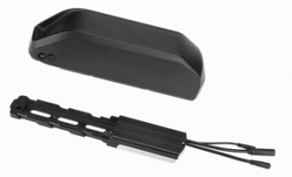
CONTROLLER
Build-in 36V 17A mosfet reinforce power brushless controller with
Multiple functions features,sine wave and square wave for option

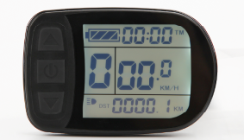
LCD
Important trip info displayed and all of the controller settings configured ,waterproof IP68
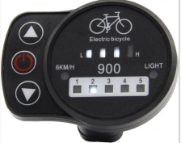

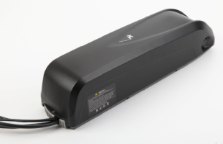
Battery
Branded 18650 cell lithium battery with high-quality BMS,RACK Type,Downtube and customized naked bag for option

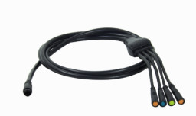
Easy-fit cabling
LVCO system comes with waterproof cabling with color coded easy fit connectors

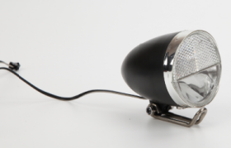

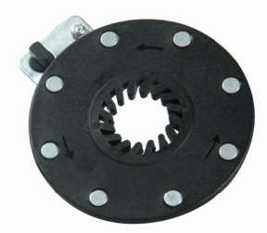
Integrated LIGHT Option
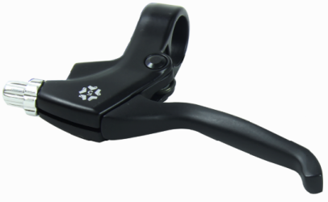
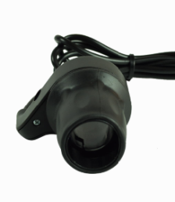
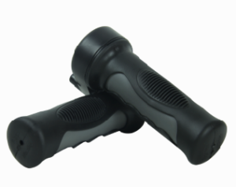
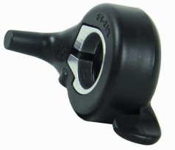

Twist/Half twist/Thumb Throttle Brake 1 pair 8 magnet PAS

