主图+3-5张细节图
MODEL：(I)NDIA SERIES
标题：
China cheap sale ebike 26" wheel 36v brushless motor conversion kit with smart controller

PRODUCT

Indian market BLDC motor kit for electric bike ,high level vehicle configuration
LVCO electric bike system including motor, battery, controller, display, cable and other accessories. we provide complete kit that including everything you need to convert your bike into an ebike. The most simple makes the best ebike.

DETAILS
36V 250w with battery internally with lithium battery

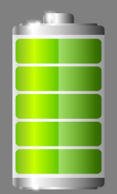
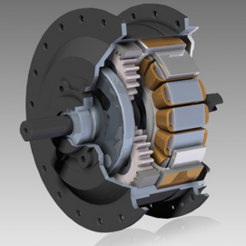
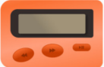
CONTROLLER
PAS

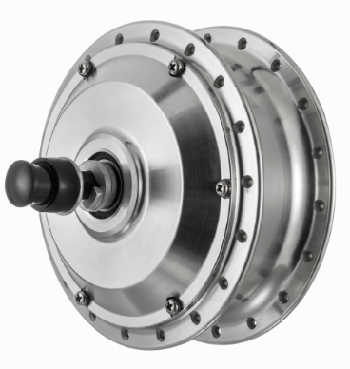

HB06R 36V 250W
brushless geared 36V/48V 250W electric bike motor, which is 42N.m. The rated speed of this
motor is 25 km/h, which is comply with the road legal of most countries.
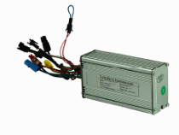
CONTROLLER
36V 14A square wave 6 multiple functions features,sine wave and square wave for option

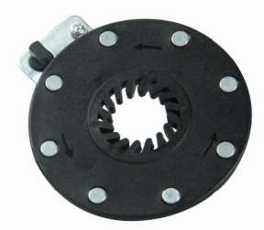
Pedal assistant
8 magnet PAS

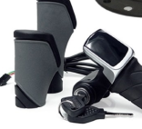
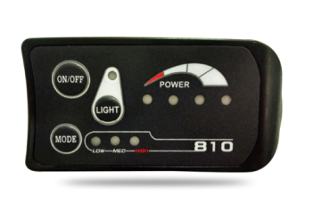
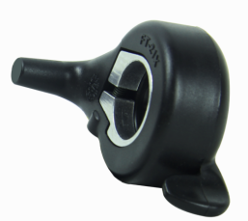

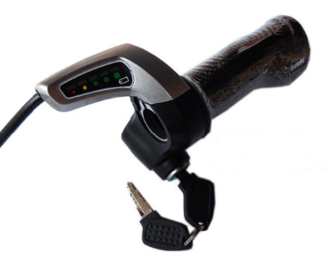

Option: Twist Throttle with indication&lock Thumb throttle &LED Display Half Twist Throttle with LCD display

