主图+3-5张细节图
MODEL：(G)ENERAL SERIES
标题：
36v 250w electric bike kit ebike conversion kit
PRODUCT

New EU standard/DISCOVER OUR EBIKE AREAS/E-ROAD/E-CITY/MTB/E-TOUR
LVCO electric bike system including motor, battery, controller, display, cable and other accessories. we provide complete kit that including everything you need to convert your bike into an ebike. The most simple makes the best ebike.

DETAILS
36v 250w electric bike kit ebike conversion kit

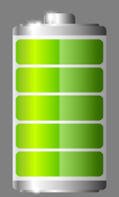
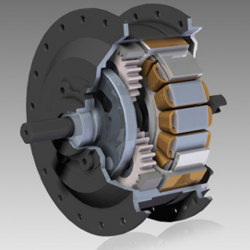
CONTROLLER
PAS

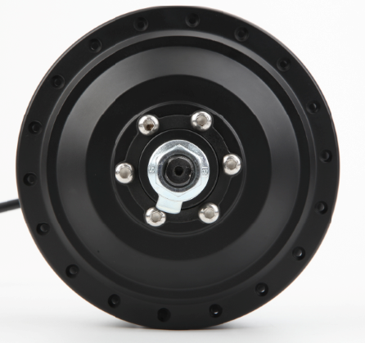

HB08R 36V 250W
brushless geared 36V/48V 250W electric bike motor, which is 42N.m. The rated speed of this
motor is 25 km/h, which is comply with the road legal of most countries.
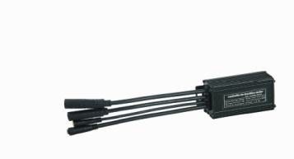
CONTROLLER
36V 14A square wave 6 multiple functions features,sine wave and square wave for option

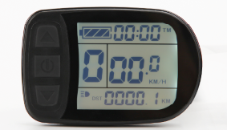
LCD
Important trip info displayed and all of the controller settings configured ,waterproof IP68

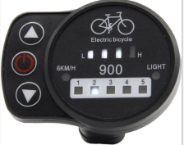

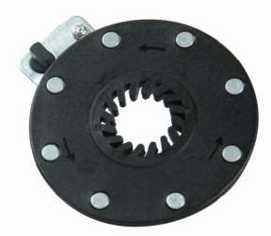
Pedal assistant
8 magnet PAS

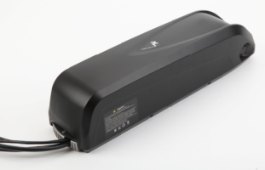
Battery
HL&RACK battery 36V 13Ah Branded 18650 cell lithium battery with high-quality BMS,RACK Type,Downtube and customized naked bag for option

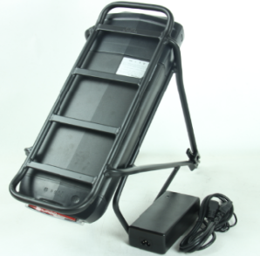

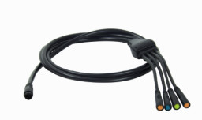
Easy-fit cabling
LVCO system comes with waterproof cabling with color coded easy fit connectors

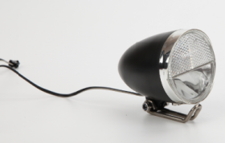
Integrated LIGHT Option

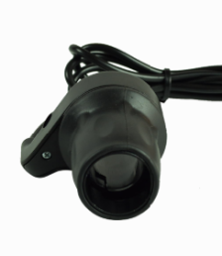
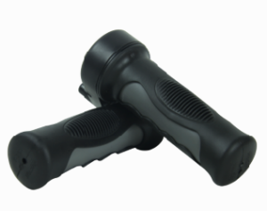
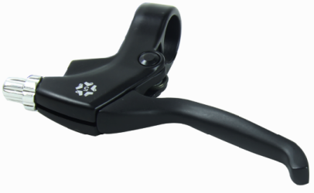
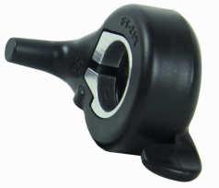

Twist/Half twist/Thumb Throttle Brake 1 pair 8 magnet PAS
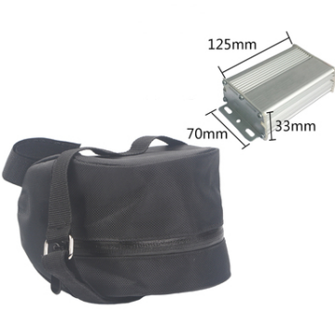

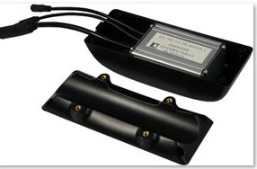

CONTROLLER BAG OPTION CONTROLLER BOX OPTION

