主图+3-5张细节图
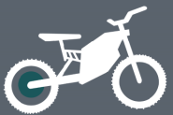
MODEL：(P)OWER SERIES
标题：
POWERFUL MOTORCYCLE CONVERSION KIT 72V 3000/72V 5000W
PRODUCT

Ideal for conversion kits, bicycle conversion kit and motorcycle conversion kit.
LVCO electric bike system including motor, battery, controller, display, cable and other accessories. we provide complete kit that including everything you need to convert your bike into an ebike. The most simple makes the best ebike.

DETAILS
72V 5000w with battery

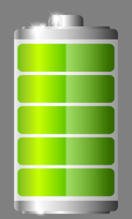
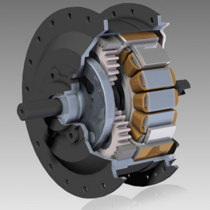
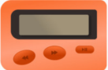
CONTROLLER
PAS

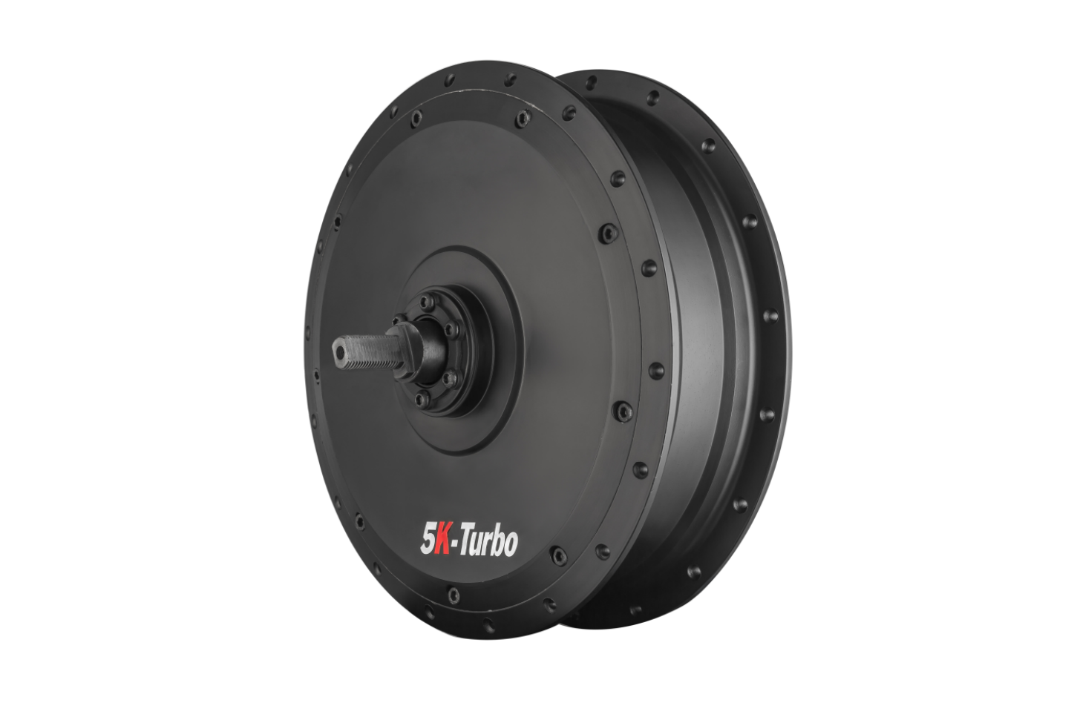

HB V5 48V/72V 3000W 72V/96V 5000W
brushless geared 72V 3000W/72V 5000W electric bike motor.High Efficiency. Max. Efficiency is 90%, save battery power, run more distance per charge.

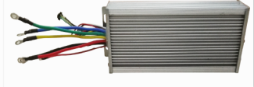
CONTROLLER
72V 100A square wave
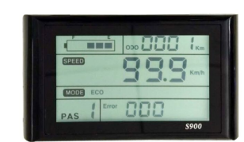

DISPALY LCD

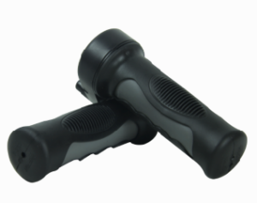

Twist Throttle

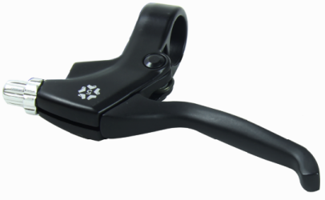
Brake 1 pair
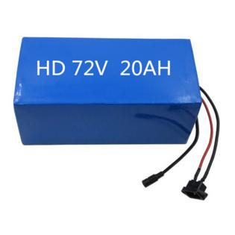

BATTERY
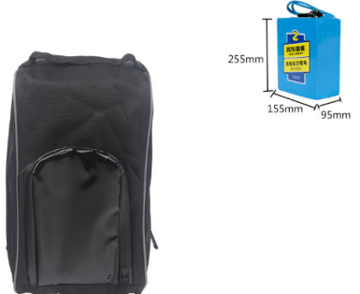
Branded 18650 cell lithium battery with high-quality BMS,RACK Type,customized naked bag fooption

Controller&Battery bag

