主图+3-5张细节图
MODEL：(C)ENTER SERIES
标题：
LVCO EBIKE BBS01 36V 250W Mid Drive Kit

PRODUCT

160N.m Torque CENTER DIRVE EASY ASSEMBLY/Efficiency
LVCO mid-mounted motor is easy to install and is suitable for bicycles with a bottom bracket width of 68/100/120mm;The motor is small in size and has a large torque. The maximum 160N.m can provide super-strong explosive force for the vehicle;It adopts vector controller, high reliability and high efficiency drive unit, low power consumption and longer mileage.

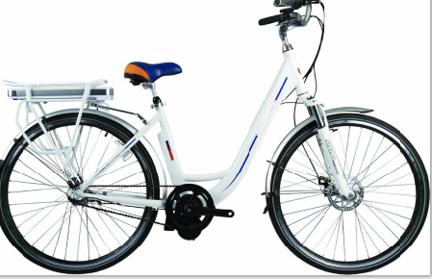

DETAILS
EBIKE BBS01 36V 250W Mid Drive Kit

Size | 25*136*101MM
Rated Voltage | 36V/48V
Rated power | 250w/350w/500w
Max speed | 30km/h
Torque | 145N.m
Weight | 4kgs
Sensor | Speed sensor
IP | 65
Dispaly | LCD

