主图+3-5张细节图
MODEL：(F)OLDING SERIES
标题：
FOLDING EBIKE KIT 16/20INCH 250W

PRODUCT

We want to pursue folding ebike minimalist, classic and functional style.
LVCO electric bike system including motor, battery, controller, display, cable and other accessories. we provide complete kit that including everything you need to convert your bike into an ebike. The most simple makes the best ebike.

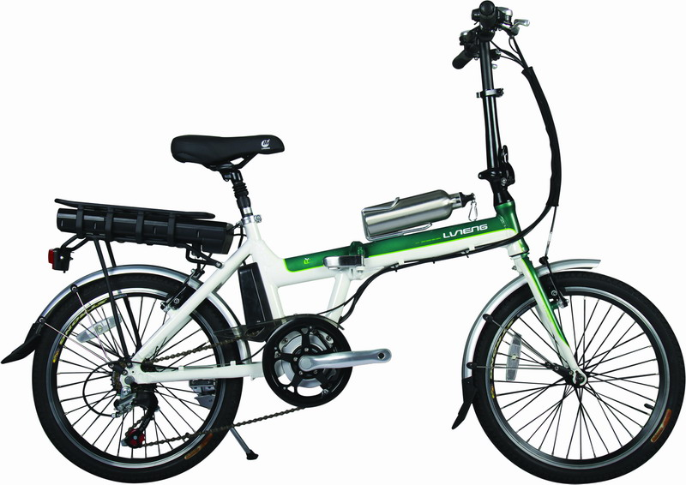
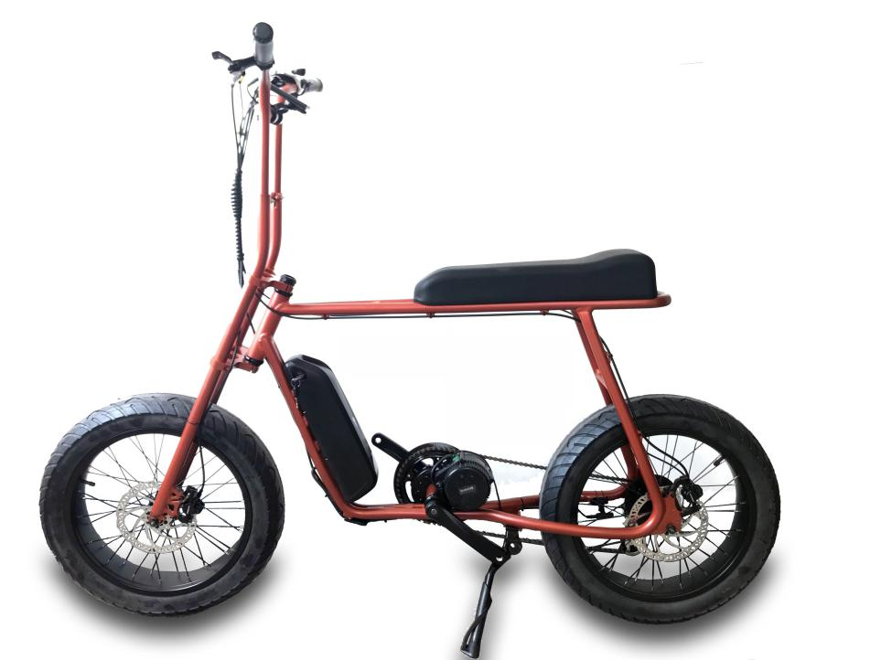
CONTROLLER INTERGRATED
CONTROLLER EXPOSED
CONTROLLER INTERGRATED

DETAILS
36V 250w ebike kit internally with lithium battery

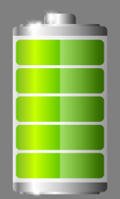
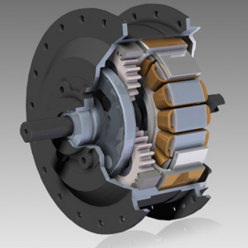
CONTROLLER
PAS

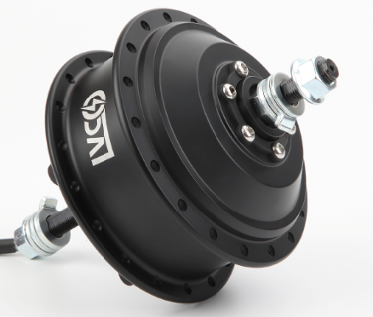

HB08F FRONT 36V 250W

brushless geared 36V/48V 250W/350W electric bike motor, which is 42N.m. The rated speed of this
motor is 25 km/h, which is comply with the road legal of most countries.

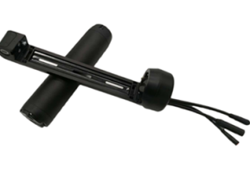
CONTROLLER
Controller build-in 36V 14A 6 mosfet reinforce power brushless controller with
Multiple functions features,sine wave and square wave for option

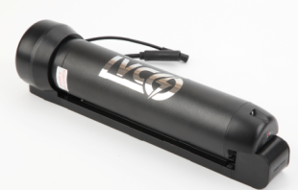
Battery HT battery 7Ah
Branded 18650 cell lithium battery with high-quality BMS,RACK Type,Downtube and customized naked bag for option

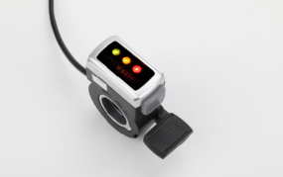
Throttle with button DX16

