主图+3-5张细节图
MODEL：(F)AT SERIES
标题：
LVCO FATBIKE 36V 250W /36V 350W USB COLORFUL HIGH CONFIGURATION

PRODUCT

DISCOVER OUR EBIKE AREAS E-FAT
LVCO electric bike system including motor, battery, controller, display, cable and other accessories. we provide complete kit that including everything you need to convert your bike into an ebike. The most simple makes the best ebike.

CONTROLLER INTERGRATED
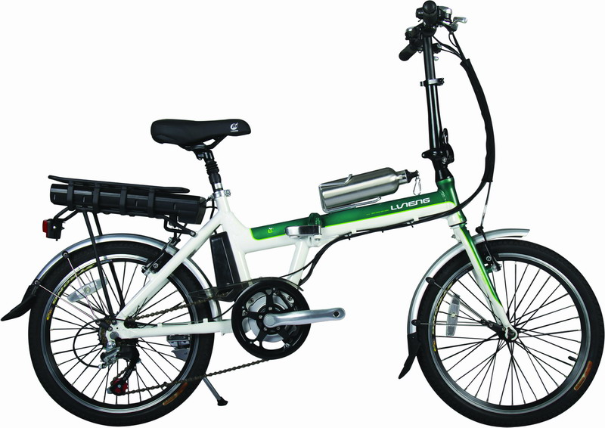
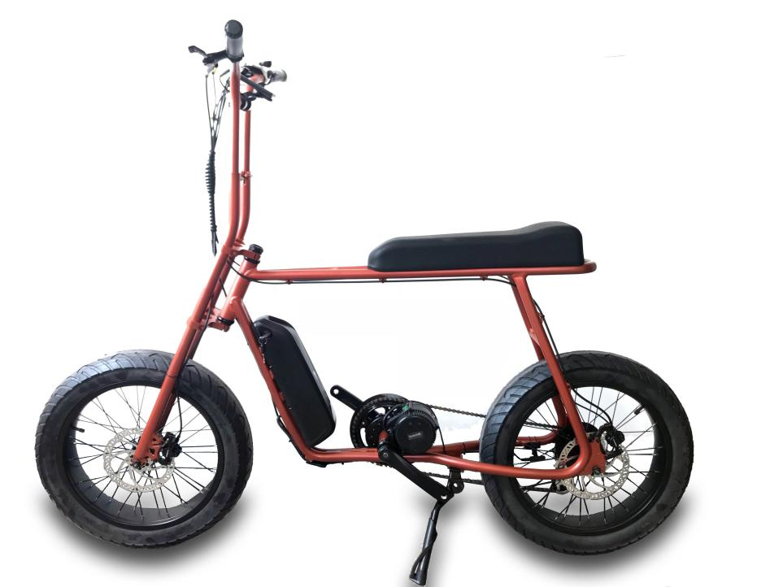
CONTROLLER EXPOSED
CONTROLLER INTERGRATED

DETAILS
36V 350W conversion kit ebike with lithium battery

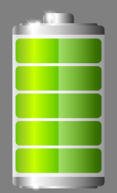
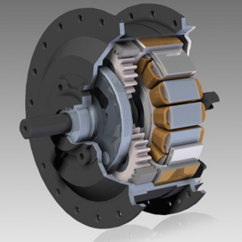
CONTROLLER
PAS

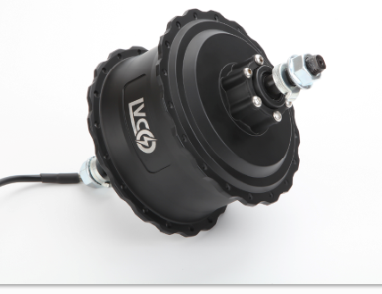
HB15FAT 36V 500W MOTOR

High torque 500W geared brushless motor,V brake and disc brake
compatible , top speed 50KPH,spoked wheel and casting wheel both
available.

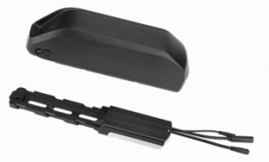
CONTROLLER
Build-in 36V 17A 9 mosfet reinforce power brushless controller with
Multiple functions features,sine wave and square wave for option

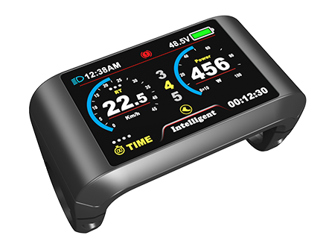

LCD 750C/850U
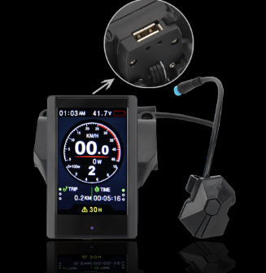
Colorful with USB .Important trip info displayed and all of the controller settings configured ,waterproof IP68

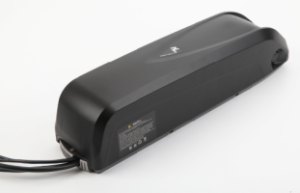
Battery HL battery 36V 13Ah
Branded 18650 cell lithium battery with high-quality BMS,RACK Type,Downtube and customized naked bag for option

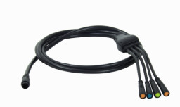
Easy-fit cabling
LVCO system comes with waterproof cabling with color coded easy fit connectors

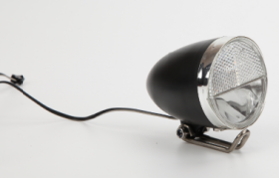

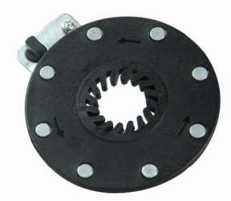
Integrated LIGHT Option
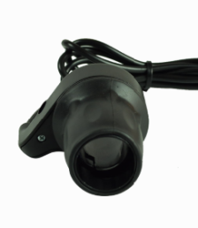
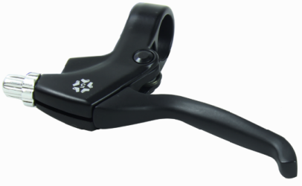
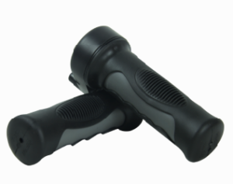
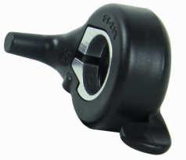

Twist/Half twist/Thumb Throttle 1 pair 8 magnet PAS

